**Assignment – 2**

**Analytics with Hospital health care data**

|  |  |
| --- | --- |
| Assignment Date | **06 November 2022** |
| Student Name | **Naveen Kumar R** |
| Student Roll Number | **720719104115** |
| Maximum Marks | **2 Marks** |

Challenges :

+ Upload the dataset to Cognos Analytics ,Prepare the data, explore and create interactive Dashboard.

**Solution :**

# **TASK -1** : Sales by Customer

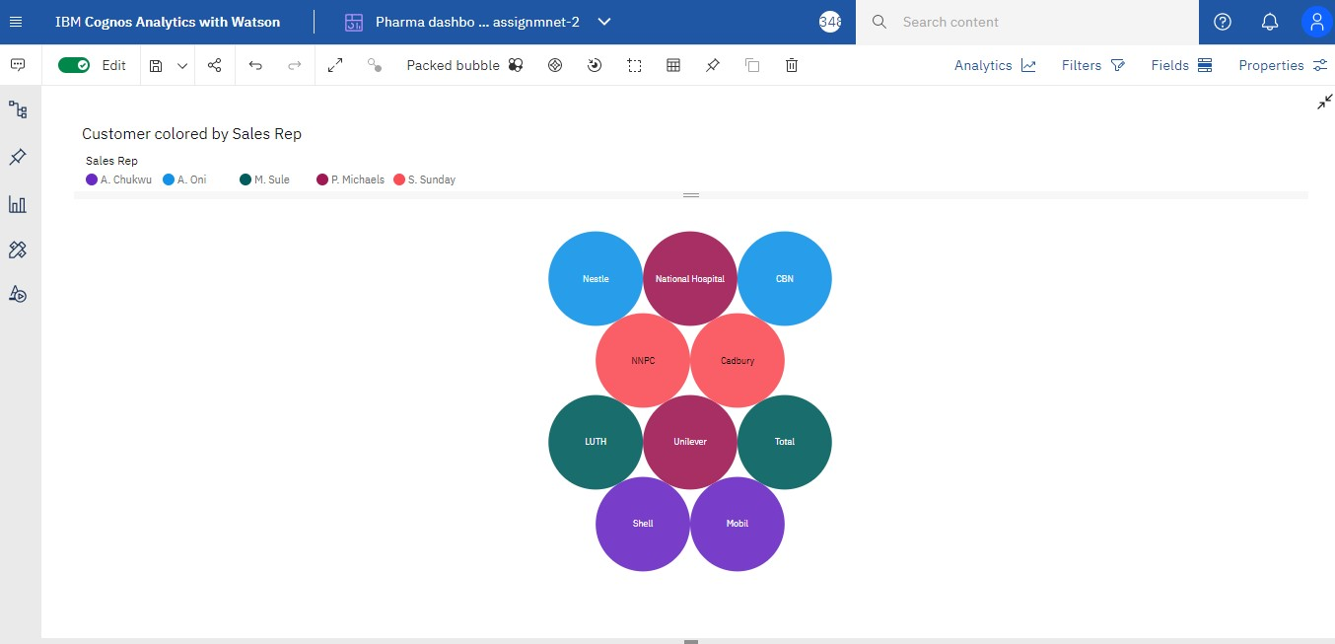

# **TASK-2** : Sales by Location

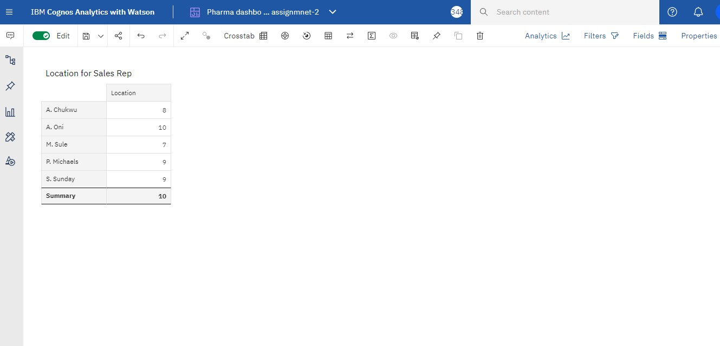

**TASK-3** : Sales by Sales Representative

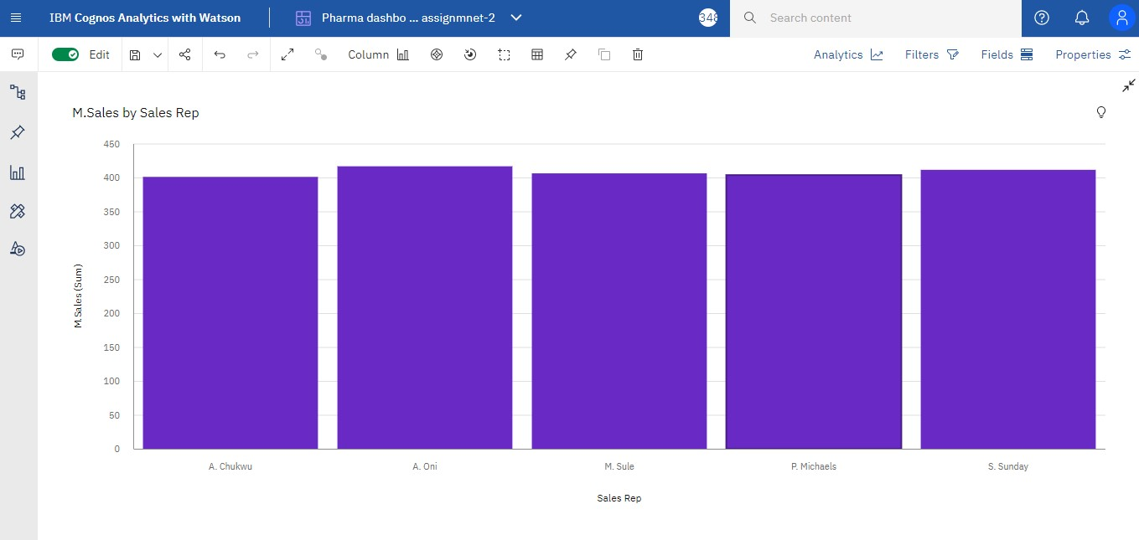

**TASk-4 :** Recevied Inventory From supplier

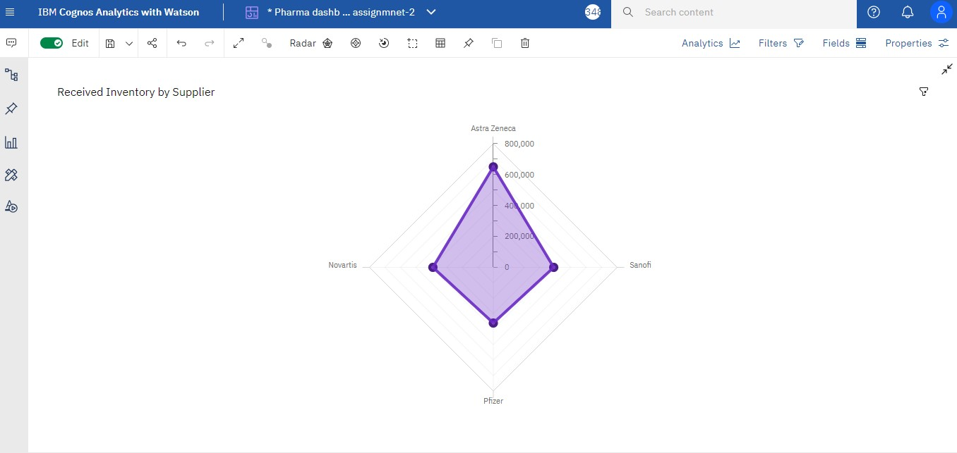

**TASk-5 :** Inventory Stock for warehouse Location

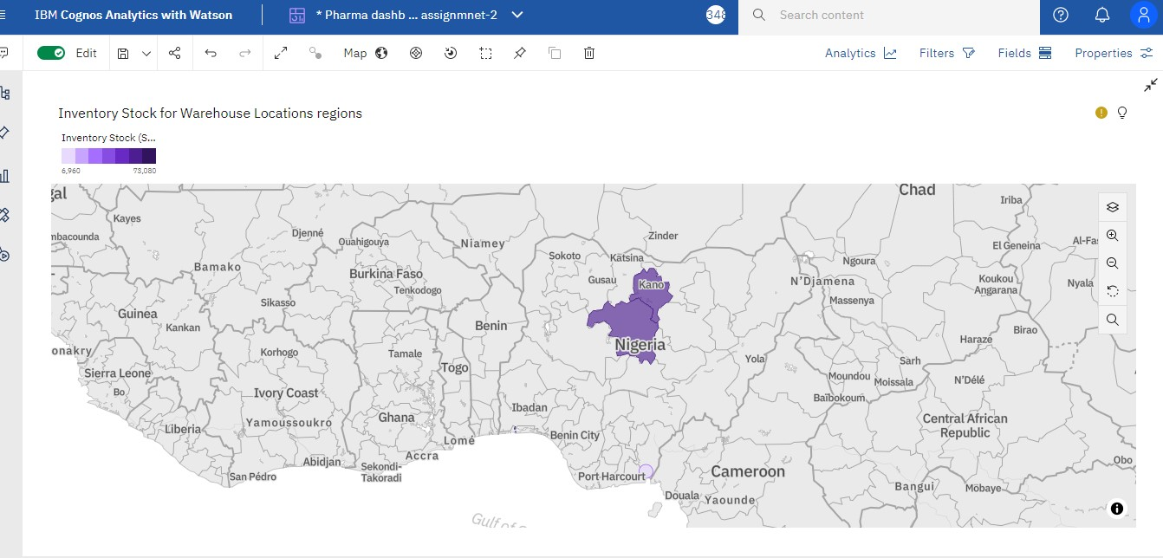

# **TASk – 6 :** Sales Trend

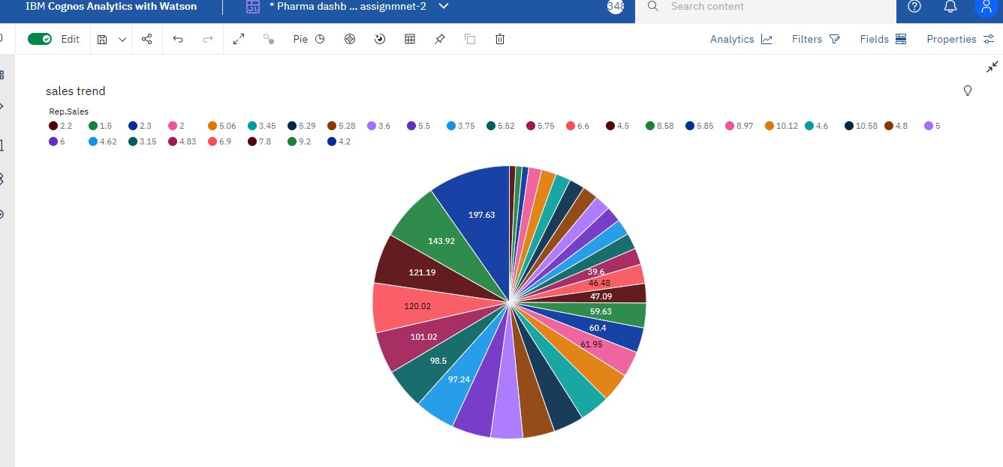

**TASK 7 :** Monthly Sales

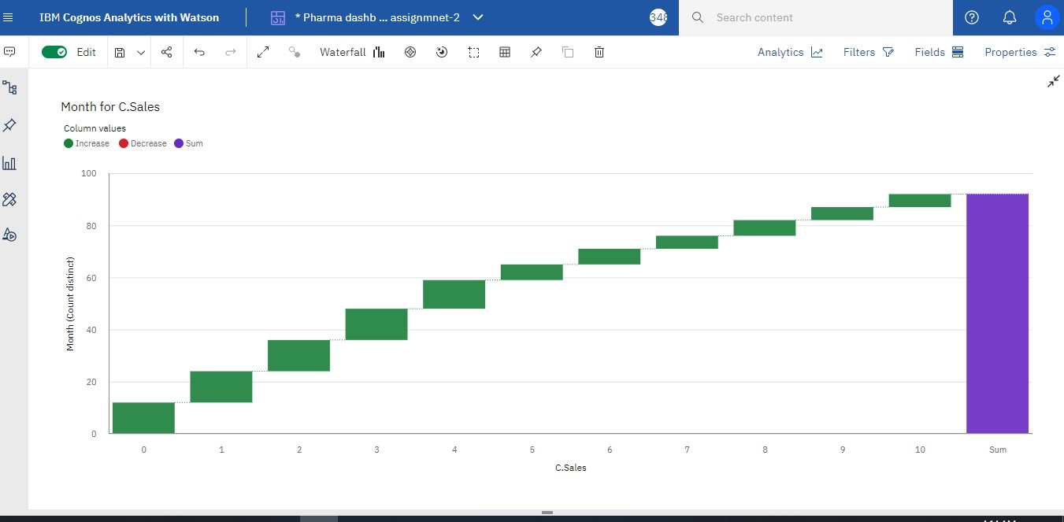

**TASK 8 :** Actual and Received Inventory by Month

